Trace2Win

Robert Li, Seunghoon Park, Hansong Peng, Angela Wu

# User Manual

## Main Menu

When you start the app, you begin at the main menu screen (fig. 1). Here you will find a navigational menu where you can create and practice characters, words, and lessons, as well as import and export sets of lessons.

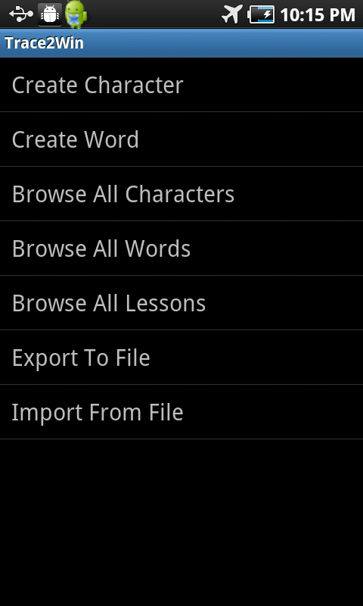

Fig. 1 MainMenuActivity

## Creating a Character

Let’s start by making your first character! Select “Create Character” to be taken to the creation screen (fig. 2). Here, you can draw your character in the dark gray box. The app will remember your stroke order, so be careful to draw it correctly! If you need to start over, press the clear button. When you’re done, press the save button to save your character.

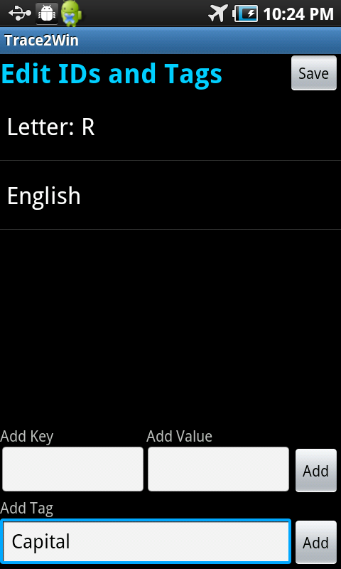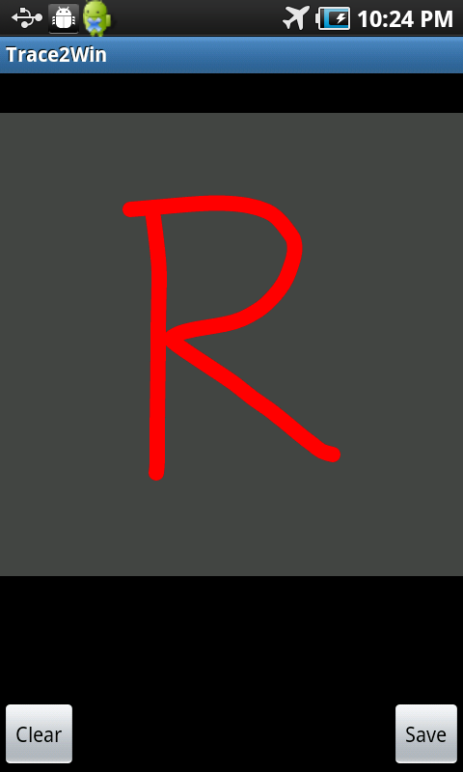After you save the character, you’ll be taken to the ID and tag screen (fig. 3), where you can add IDs (key-value pairs) and tags to identify and classify your new character. Press the save button to go back to the main menu when you’re done.

Fig. 2 ViewCharacterActivity Fig. 3 TagActivity

## Viewing Characters

After creating a character, view it by selecting “Browse All Characters” from the main menu (fig. 4). Clicking on the character will take you to the character view screen (fig. 5), and long pressing on a character will allow you to edit its tags, delete it, or reorder it.

From the character view screen, toggle between playback and practice mode using the buttons in the bottom-right corner. If you need to edit the character, you can return to the character creation screen by pressing the edit button.

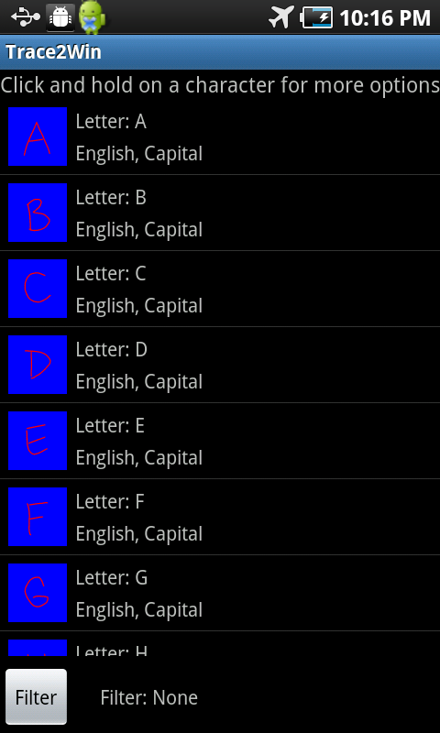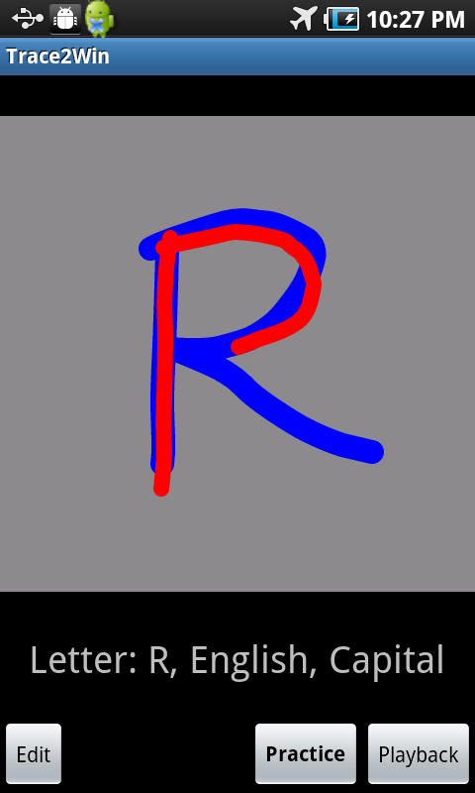Fig. 4 BrowseCharactersActivity Fig. 5 ViewCharacterActivity

## Creating a Word

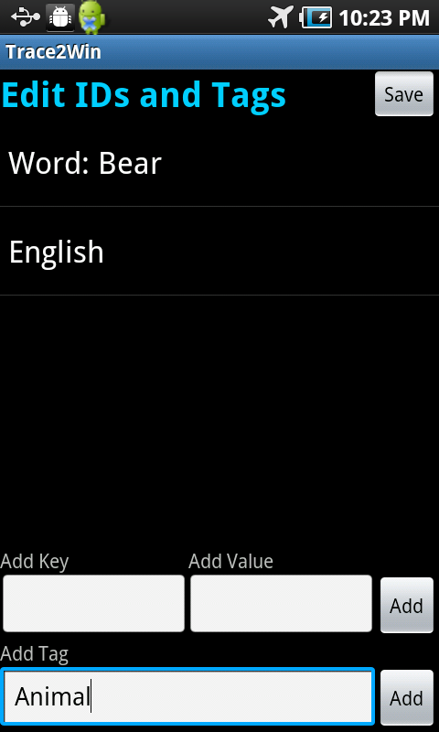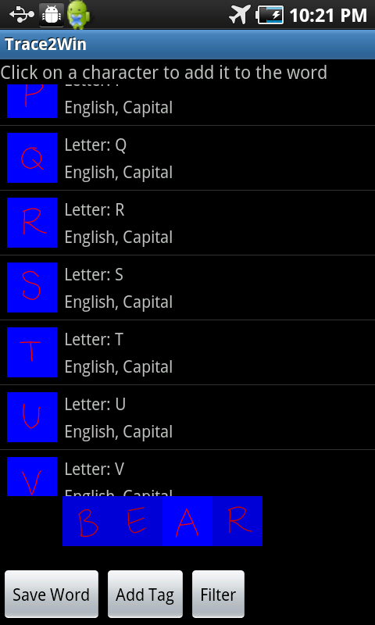Let’s create a word by selecting “Create Words” from the main menu—this takes you to the word creation screen (fig. 6). Create your word by selecting the characters it’s composed of, one by one. When you’re done, click the save word button, and save the word to a lesson. Then, you can click the add tags button to add IDs and tags to the word (fig. 7). This is the same process as adding it to characters.

Fig. 6 CreateWordActivity Fig. 7 TagActivity

## Viewing Words

To view words, select “Browse All Words” from the main menu (fig. 8). Clicking on the word will take you to the word view screen (fig. 9), and long pressing on a word will allow you to add it to a lesson, edit its tags, delete it, or reorder it.

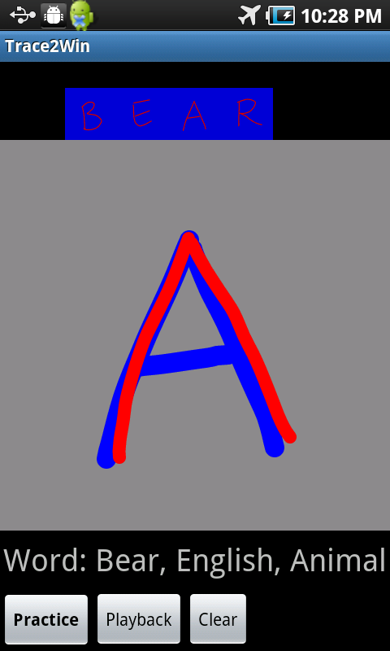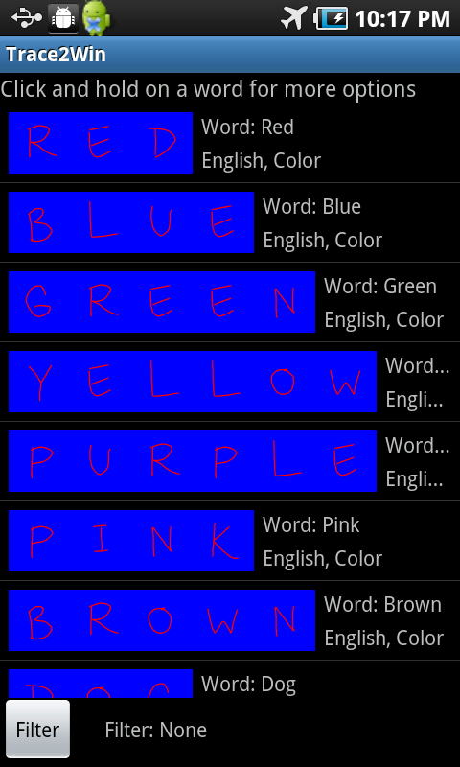From the word view screen, toggle between playback and practice mode using the buttons in the bottom-left corner. In practice mode, you will automatically progress to the next character after you finish tracing the current one. To view a particular character in the word, click on that character in the word at the top of the screen.

Fig. 8 BrowseWordsActivity Fig. 9 PhrasePracticeActivity

## Viewing Lessons

All of your lessons can be viewed by selecting “Browse All Lessons” from the main menu. This takes you to the browse lessons screen (fig. 10), where you can select an individual lesson and view the words it contains. When practicing a lesson, you will automatically progress to the next word once you finish tracing the current one.

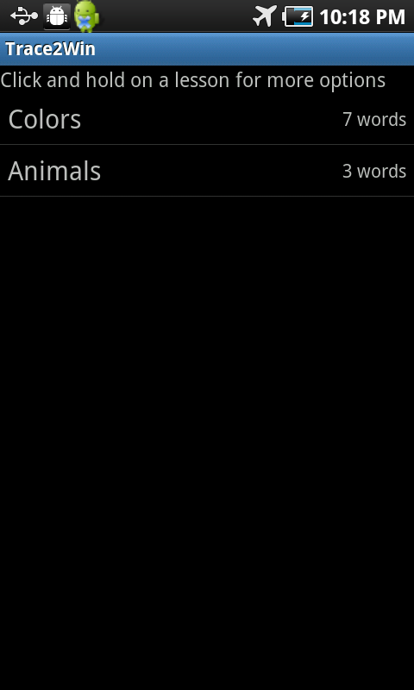

Fig. 10 BrowseLessonsActivity

## Import and Export

Trace2Win is considered an admin app, and as such, is the only way to create characters, words, and lessons. To distribute these to a user, we will export to a file on the SD card. Begin by selecting “Export To File” from the main menu, which brings up the export screen (fig. 11). Select the items you would like to export. Note that “All Characters” will export every character that’s currently on the app. When you’re done, click the export button to create a new bundle. Note that the file extension “.ttw” will be added to the name of the bundle.

To import a TTW file, select “Import From File” from the main menu. This brings you to the import screen (fig. 12). Select the bundle you’d like to import, and the app will import the characters, words, and lessons. Every item will be added, and none of your current items will be lost. However, if the import contains an item that you already have, it will be ignored, i.e. no duplicate item will be created.

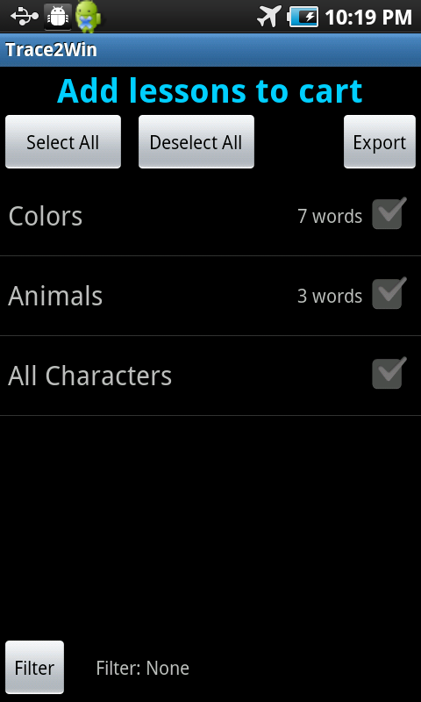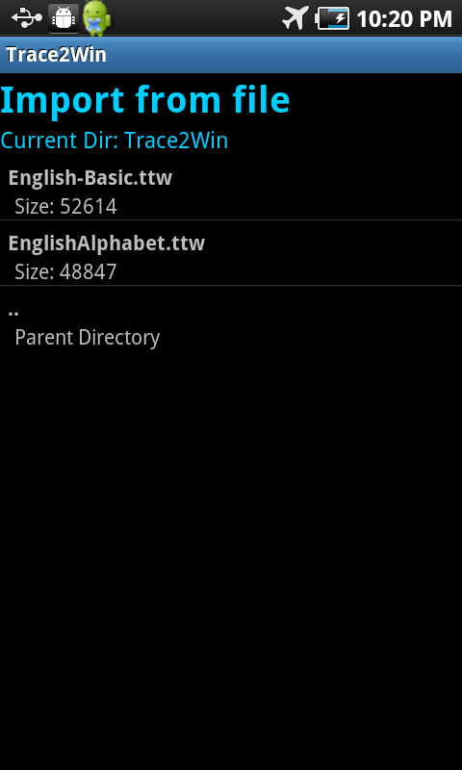Fig. 11 ShoppingCartActivity Fig. 12 FilePickerActivity

## TraceThis

As mentioned above, Trace2Win is an admin app. The user app, called TraceThis, is a stripped down version of Trace2Win, and simply has items removed from the main menu (fig. 13). Each item functions the exact same way as the admin app.

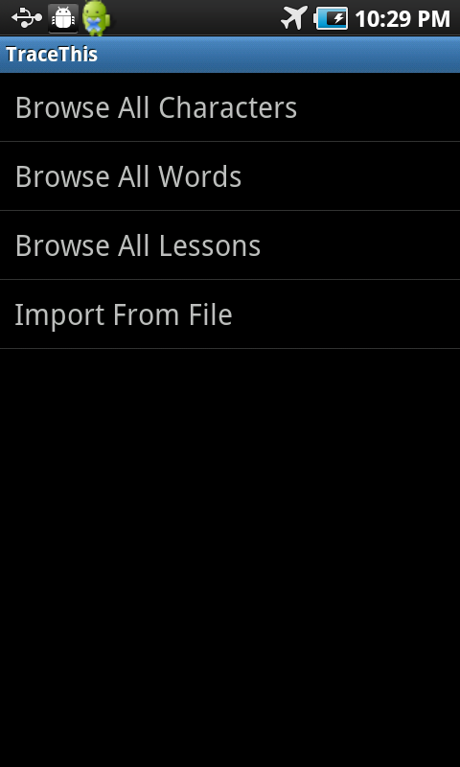

Fig. 13 TraceThis.MainMenuActivity

# Technical Documentation

## Fig. 1 MainMenuActivity

It displays available menus to the user. The rest activities are implemented in the ‘TraceLibrary’.

## Fig. 2, Fig. 5 ViewCharacterActivity

This activity is used when creating a character and displaying a character to the user.  
When displaying, there are two different modes: Practice and Playback.

## Fig. 3, Fig. 7 TagActivity

This activity displays key-value pairs and tags of the selected LessonItem which has three different types: CHARACTER, WORD, and LESSON. The user also can add/edit/delete key-value pairs and tags.

## Fig. 4 BrowseCharactersActivity

This activity displays saved characters and has a filtering feature.

## Fig. 6 CreateWordActivity

This activity displays saved characters and lets the user select them to create a word.

## Fig. 8 BrowseWordsActivity

This activity displays saved words and has a filtering feature.